Appendix – Blank Template

Front-End Web Development Project Planning Template
Project Name: Music Vault

Group Number: 2
Student Name: Marco (P2617956), Mun Yu(P2618720), Rahul(P2618759), Muhsin (P2618449)
Student Role: Marco (Design Lead), Mun Yu(Technical Support), Rahul (Leader), Muhsin (Technical Support)
Class: DCITP/FT/1A/11

  - PROJECT BASICS
Chosen Theme: Music

Why have you chosen this topic? (Explain your personal connection or interest in this sustainability theme in not 3~4 sentences)
Music is such a large aspect of the young generation’s lives, standing with them through thick and thin in their most defining years. Yet, most young listeners treat it as background noise that can be controlled through basic playlist labels. We want our project to transform these listeners into appreciators by unpacking the structure, history, and emotion behind sound, and we want to show that music is more than just a pastime.

Target Audience: Youths in Singapore

Main Goal: What do you want visitors to learn or do after visiting your website?
Our main goal is to transform passive listeners into open-minded, active appreciators of music by exploring the beauty, history & cultural importance of music among visitors. We want to foster the spirit that music is more than just background noise or a pastime; we want to show that it actually has significance, and people should appreciate its significance.

  - CONTENT OUTLINE
Key points of each page:
List main points you will cover through your pages.
Home:
• Introduce the purpose of our webpage, why it was made and our goal
• Introduce our website details (What the user is going to experience by going through our page)

Interactivity: Will have an interactive music player that allows users to listen to songs.

About Music:
• Introduction to what music is and the various elements involved, such as pitch, rhythm, timbre, etc
• How they interact with each other to shape different yet distinct musical characteristics and styles

Interactivity: Floating notes that users can play and feel around with, as well as interactive sheet music that users can click and learn the different notes from it. There are also other interactive items that users can click to interact with.

History of Music:
• Explore the origins and history of music, and its earliest forms
• Exploring how music was brought through the years, and how much it changed from old classics to new generation hits.
• Exploring how music was made into a recognised form of art and creative expression that people can now pursue, and its revolutionary impact on society.

Music Genres:
• We will allow users to explore a wide variety of genres, their characteristics and history
• How it has evolved to become what it is now
• Give a taste of different genres by playing a snippet or recommending some tracks for each genre

Interactivity: There will be music players that users can play around with to listen to songs from the different genres.

Famous Artists:
• Explore the different influential artists and releases that shaped each genre
• Describe their impact on music, such as Michael Jackson, who was named the “King of Pop”.

Musical Instruments:
• Introduce the different families of instruments, such as percussion, strings and winds
• Its evolution from its primitive and earliest forms to what it is now.

Benefits of Music:
•Show users the uses of music, from being helpful in mental health to being used to cure illnesses
•How it brings people and communities together
•Showing that music really brought colour to the world & without it, the world would really be a bland place.

Music Around the World:
•Introduce different kinds of music from different parts of the world, highlighting their cultural and musical influences.
•Explain how music from some countries shaped the music we listen to today

Music Technology:
• Go through how different technological advancements have shaped how we create and experience music, such as how Beatles songs popularised the use of synthesisers, or streaming platforms making music more accessible to various groups of people

Live Music & Concerts:
• Explain what makes live music experiences and concerts different from streaming it on your headphones
• How these events evolved and changed over decades
• Iconic concerts and their significance.

Top Albums & Songs:
• “Hall of Fame” of iconic releases and albums that defined their genre and shaped future generations of artists

3. DESIGN APPROACH

Colour Scheme | What colour scheme will be used?  Black, Gold and Green. Black creates a strong contrast, making text and images easier to read while making the images stand out.
Overall Style/Mood | What is the overall style/mood to be used?  Luxurious, premium and easy on the eyes.

Brief description how you will apply C.R.A.P. Principles?
Contrast | How will you use contrast to make important elements stand out?  -Use bold headings with high-contrast colours against the background.  - Highlight important buttons (such as "Explore Genres" or "Learn More") using bright accent colours.
Repetition | What design elements will you repeat throughout your site for consistency?  -Use the same typography, colour, and button styles across every page.  - Consistent margin and padding sizes between elements  - Keep the same navbar and footer across every page.
Alignment | How will you align text and elements on your pages?  - Align text and images neatly using a grid layout.  - Keep headings, paragraphs, and buttons consistently aligned to make the website easy to read and navigate
Proximity | How will you group related information together?  - Grouping related content into clearly labelled sections and related topics into clearly labelled pages  - Place images, audio samples, and descriptions close together so users can easily connect the information.

4. WEBSITE LAYOUT DESIGN
NOTE TO TEACHER: EACH OF THESE WIREFRAMES ARE THE STRUCTURE OR AT LEAST A REFERENCE FOR 3 OTHER PAGES, TOTALING 12 PAGES.

Interactive items kept constant through the Webpage:
- Header
- Footer (Newsletter is the Form)
- Form with interactive items such as support chat box, calendar, Username &
password, etc.

Benefits of music, musical instruments, and technology in music page wireframe :
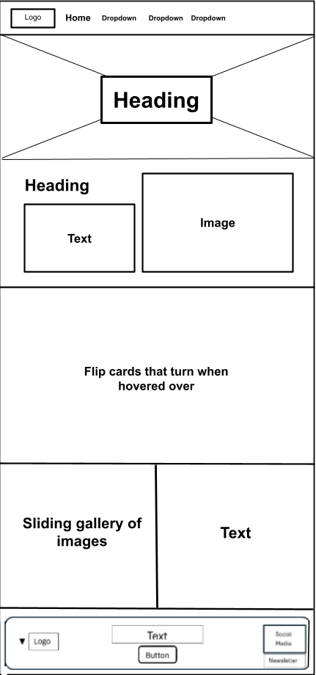

Live Music & Concerts, Top Albums & Songs, Gallery/Contact/References:
